Experiment Number: 2

NAME: **Kartik Banshi Katkar** ROLLNO: 36

CLASS: TY IT A BATCH: 1

DATE OF PERFORMANCE: 13/07/2003

___________________________________________________________________________

**Question:  
  
Write MATLAB Code for Pseudo Image coloring operation of a given image using**

**i) Intensity slicing technique and**

**ii) Gray to Colour transform**

**iii) Hybrid Model**

**Answer:**

1. **Intensity slicing technique**

% Read the input image

inputImage = imread('grayscale.jpg');

% Convert the input image to grayscale

grayImage = rgb2gray(inputImage);

% Define intensity thresholds

lowThreshold = 100; % Set the low intensity threshold value

highThreshold = 300; % Set the high intensity threshold value

% Create a binary mask based on the intensity thresholds

binaryMask = (grayImage >= lowThreshold) & (grayImage <= highThreshold);

% Create a pseudo-colored image using the binary mask

pseudoColoredImage = cat(3, uint8(binaryMask)*255, uint8(inputImage(:, :, 2)), uint8(~binaryMask)*255);

% Display the original image and the pseudo-colored image

subplot(1, 2, 1);

imshow(inputImage);

title('Original Image');

subplot(1, 2, 2);

imshow(pseudoColoredImage);

title('Pseudo-Colored Image');

**Output:**

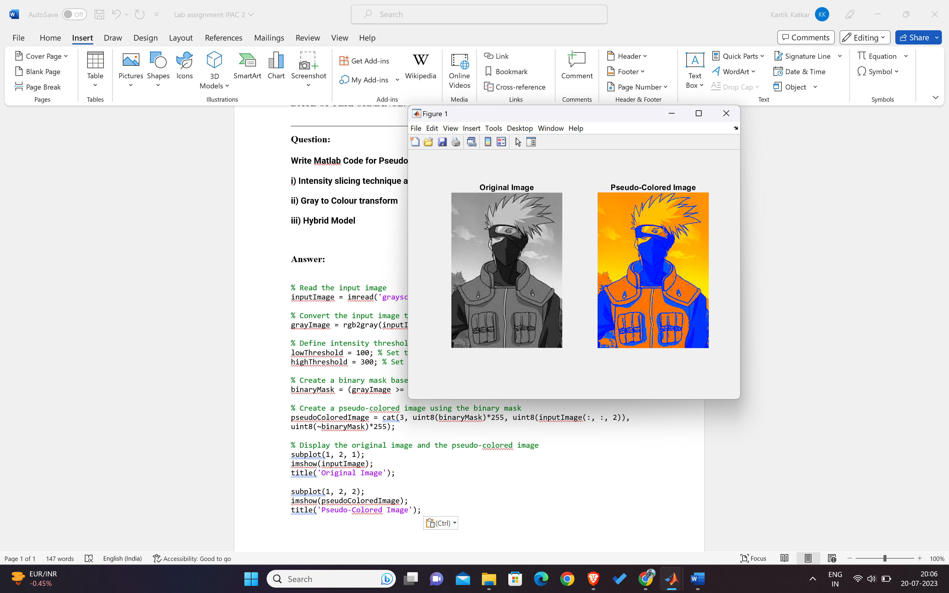

1. **Gray to Colour transform**

% Read the grayscale image

img = imread('grayscale.tiff');

% Preallocate RGB array

rgb = zeros(size(img, 1), size(img, 2), 3);

% Scaling factors for each channel (red, green, and blue)

scaling_r = 1.0;

scaling_g = 0.11;

scaling_b = 0.33;

% Apply the Gray to Colour transformation using scaling factors

rgb(:, :, 1) = scaling_r * img;

rgb(:, :, 2) = scaling_g * img;

rgb(:, :, 3) = scaling_b * img;

% Display the colored image

imshow(uint8(rgb));

**Other Variation (Changing the Scaling factor):**

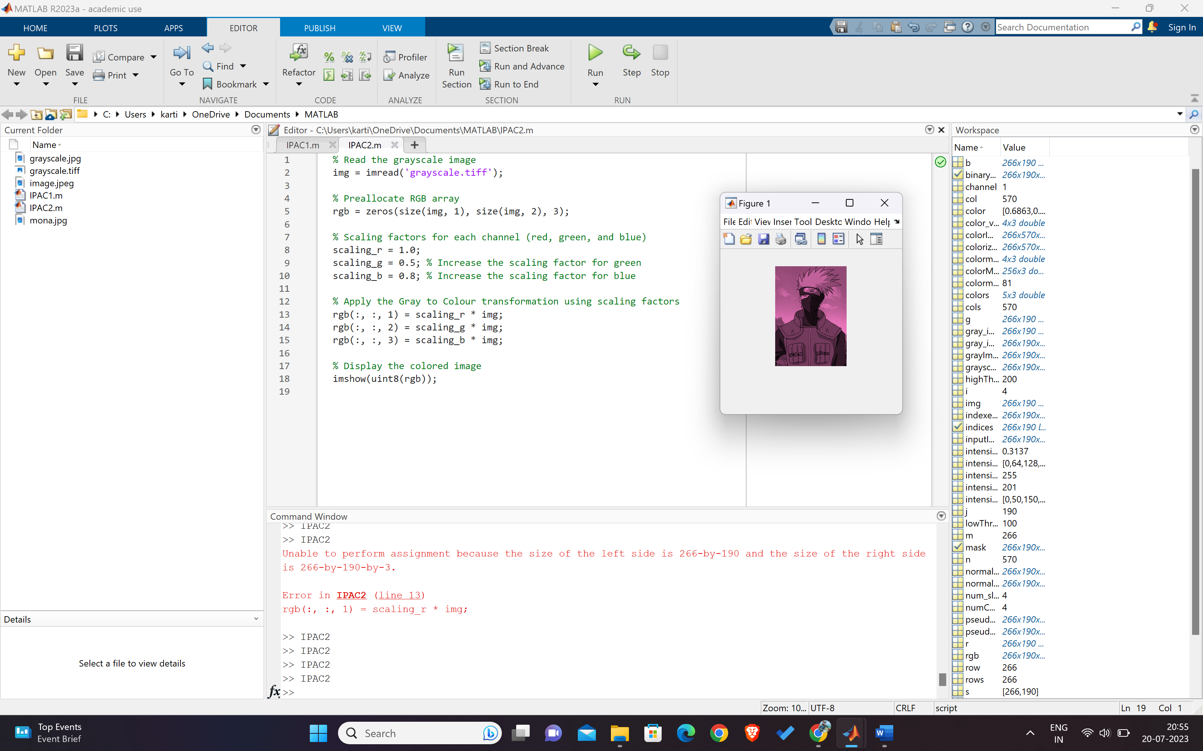

**Output:**

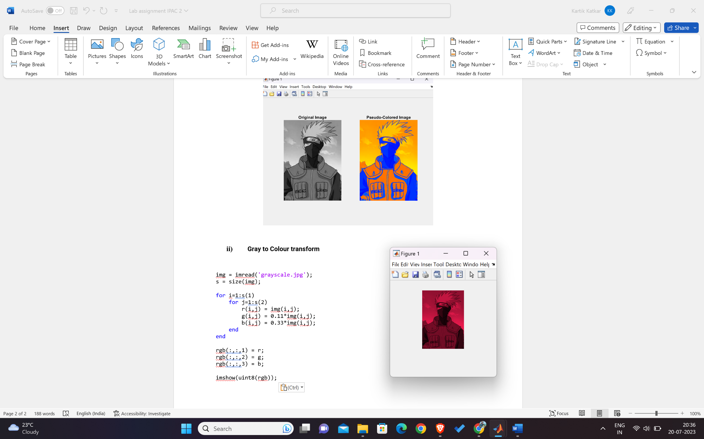

1. **Hybrid model-Using Intensity Slicing and Gray to colour transformation technique**

Input:

% Read the grayscale image

img = imread('grayscale.tiff');

% Define intensity ranges for intensity slicing

intensity_ranges = [0, 50, 150, 200, 255];

% Define color values for each intensity range

color_values = [

255, 0, 255; % Magenta (intensity 0-49)

255, 0, 0; % Red (intensity 50-149)

255, 255, 0; % Yellow (intensity 150-199)

0, 255, 0 % Green (intensity 200-255)

];

% Create the hybrid color image

rgb = zeros(size(img, 1), size(img, 2), 3);

for i = 1:length(intensity_ranges)-1

intensity_min = intensity_ranges(i) + 1;

intensity_max = intensity_ranges(i+1);

% Find the indices of pixels in the current intensity range

indices = (img >= intensity_min) & (img <= intensity_max);

% Map the grayscale intensities to specific color values

rgb(:,:,1) = rgb(:,:,1) + double(indices) * color_values(i, 1);

rgb(:,:,2) = rgb(:,:,2) + double(indices) * color_values(i, 2);

rgb(:,:,3) = rgb(:,:,3) + double(indices) * color_values(i, 3);

end

% Display the colored image

imshow(uint8(rgb));

Output:

